**Dependent-Gaussian-Process-Based Learning of Joint**

**Torques Using Wearable Smart Shoes**

**for Exoskeleton**

This paper presents a dependent Gaussian process (DGP)-based learning algorithm for joint-torque estimations with measurements from wearable smart shoes.

The statistical nature of the proposed DGP model and the composite kernel functions offer superior flexibility for time-varying gait-pattern learning, and enable accurate joint-torque estimations.

As ankle torques are the least variable among joints of lower limbs due to the constraint by the ground, many reported algorithms are keen on the estimation of ankle-joint torques . For example, an NN was adopted to estimate ankle-joint torques using a lowcost pressure insole and tendon sensor .  
The GP model was used to estimate ankle angles and torques at a specified walking speed using shank angular velocity and angle as the inputs.  
However, estimation results on knee and hip torques remain unknown.

* As joint kinematics and joint torques definitely have dependencies, data fusion is recommended to explore correlations between the kinematics and torques of a joint, and to figure out time-varying movement features in the human gait.

dependent Gaussian process (DGP) was used to address the data-fusion problems. The DGP model can be constructed by regarding the GP as filters excited with white source noise, which is a powerful mathematical tool to model various dynamic systems in terms of covariance functions.

A set of measured data, such as [x1**,**x2**,**...] for the left shoe could be acquired, including air pressure at the heel, arch, and forefoot of the sole, three orientations, and three angular velocities of the heel along the X, Y, and Z axes, respectively; and three orientations and three angular velocities of the forefoot along the X, Y, and Z axes, respectively.

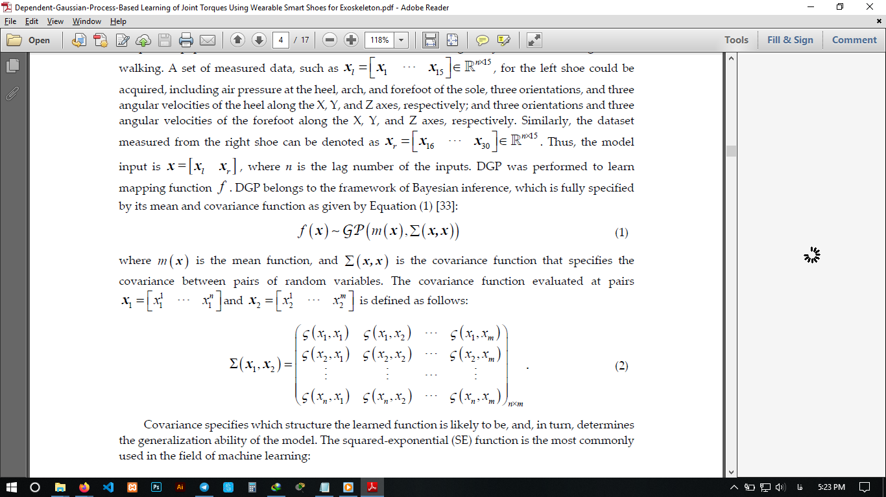

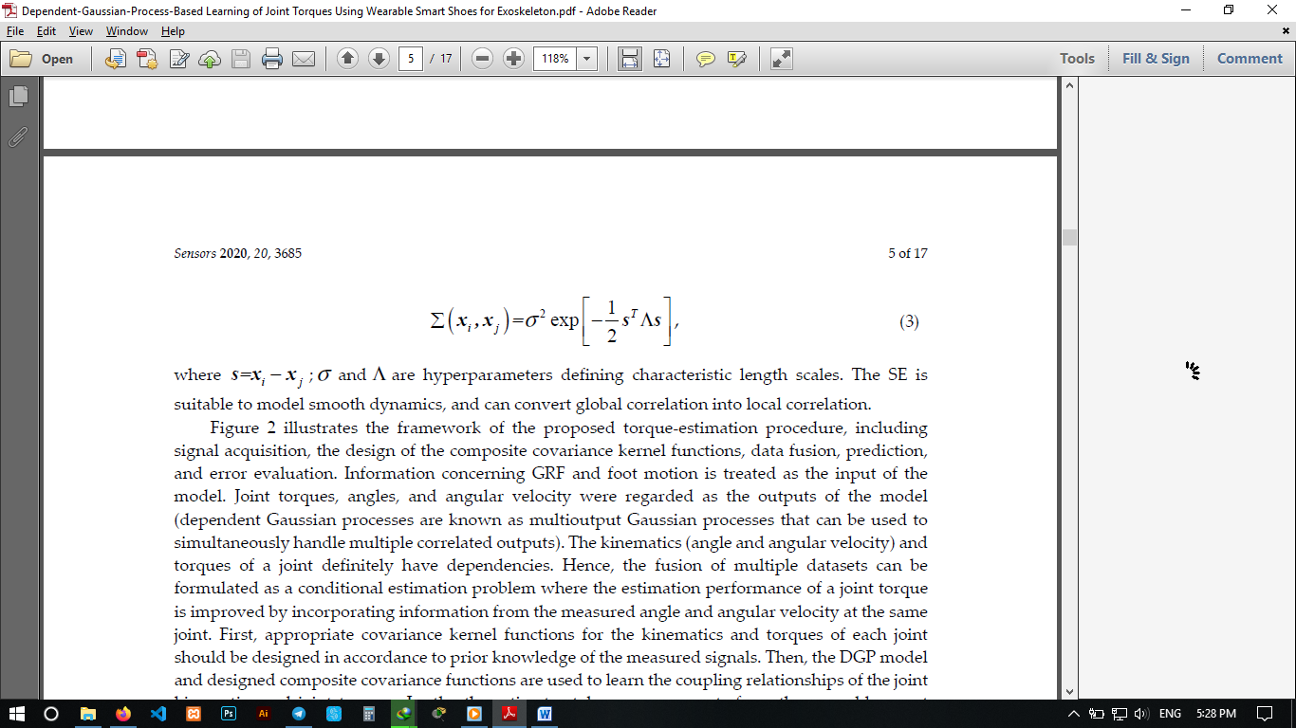

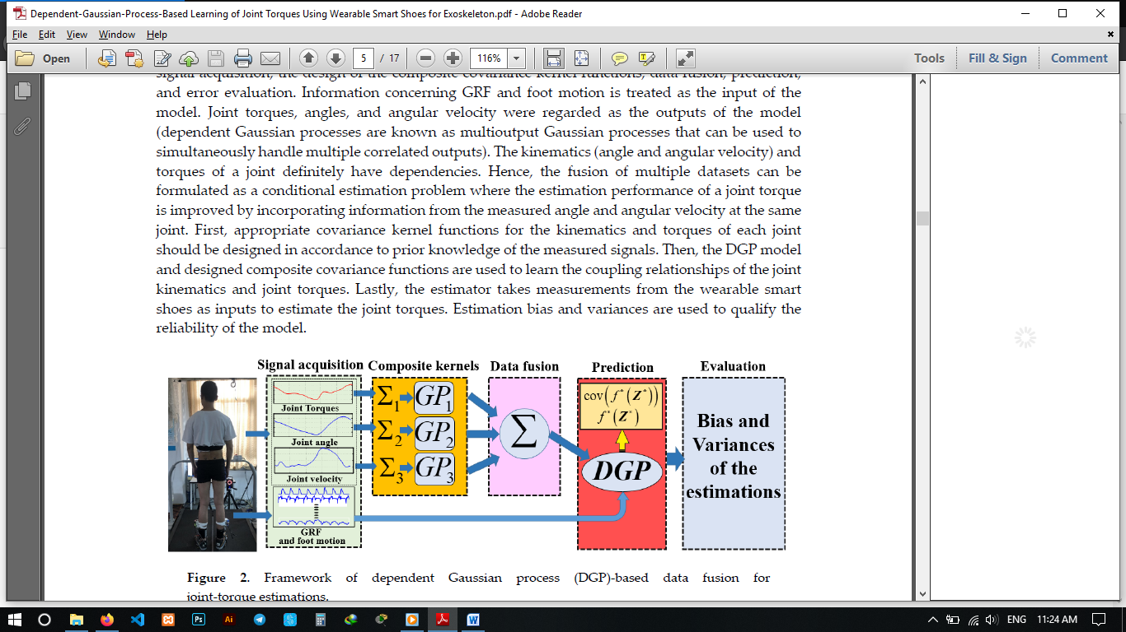

1. signal acquisition,
2. the design of the composite covariance kernel functions,
3. data fusion, prediction,
4. and error evaluation.

estimation performance is improved by learning auto-co-variance functions and cross-co-variance functions between them.

By performing DGP for joint-torque learning, a fused model can be designed by the conditional estimation of the three datasets, and it is specified in Equation.

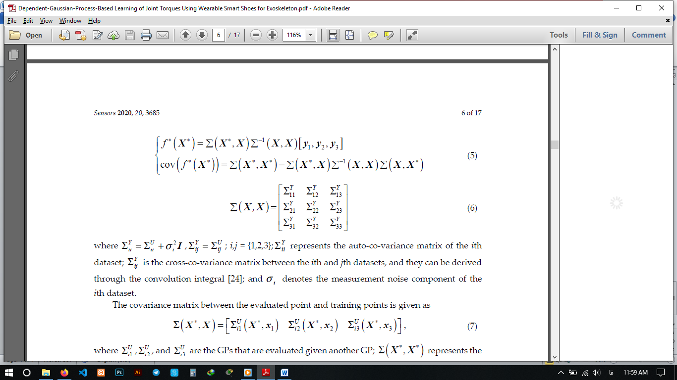

X∗ is an arbitrary location to be evaluated.  
and f ∗ and cov( f ∗ ) are the evaluated mean and covariance at X∗.

In this scenario, the leading features of the measured signals were nonlinear, containing some noise and sometimes some roughness. A summation of three different base kernels, MC, SE, and WN, was designed to model these leading features.

**Experiment Study**

optical motion-capture system

treadmill

three walking-speed levels (0.8, 1.2, and 1.6 m/s).

camera: rate of 100 Hz

Trial 1 (relating to the three walking-speed levels mentioned above) of a specific subject were used for training the DGP model, and data from Trial 2 of that subject were used for validation.

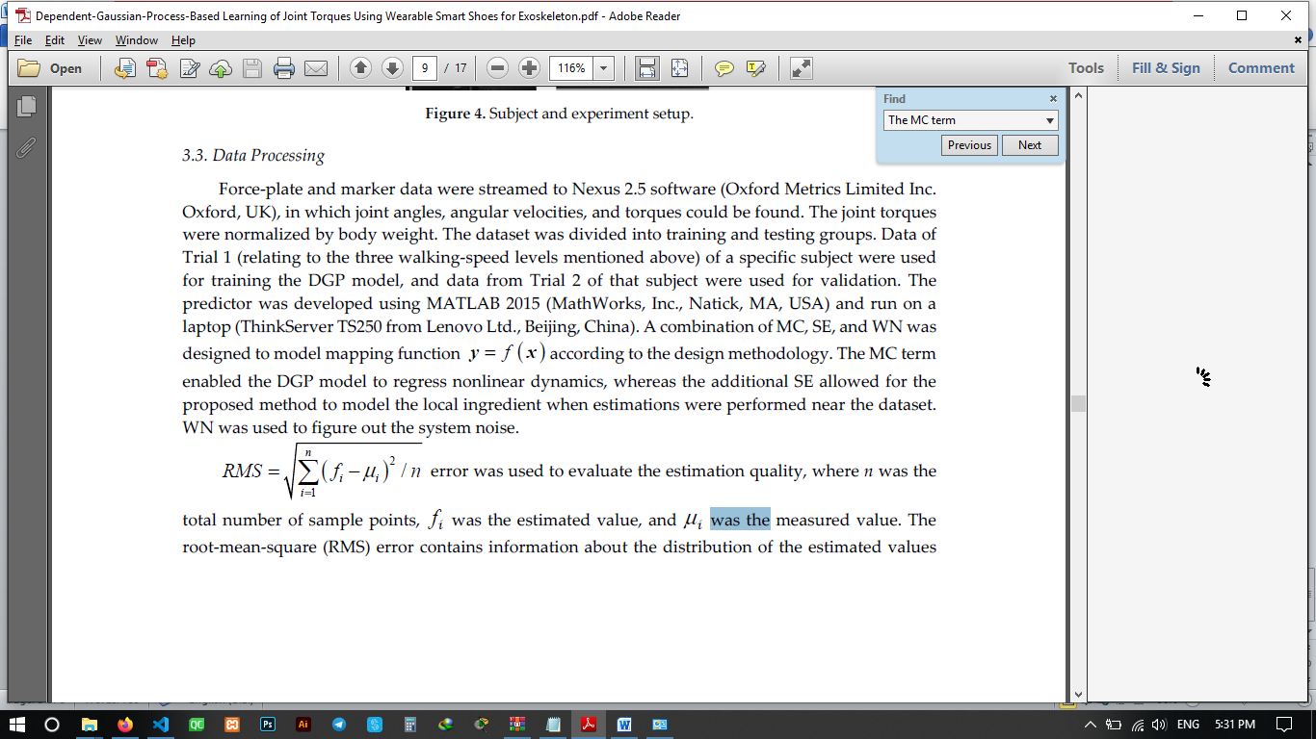

(RMS) error contains information about the distribution of the estimated values around the expected values.

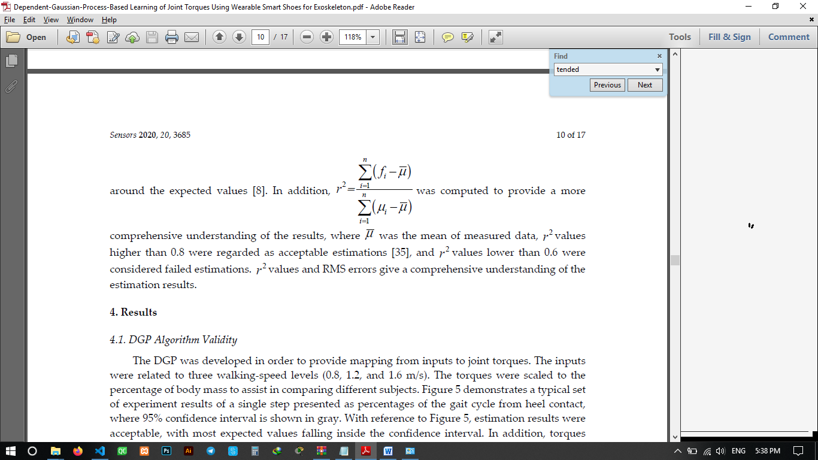

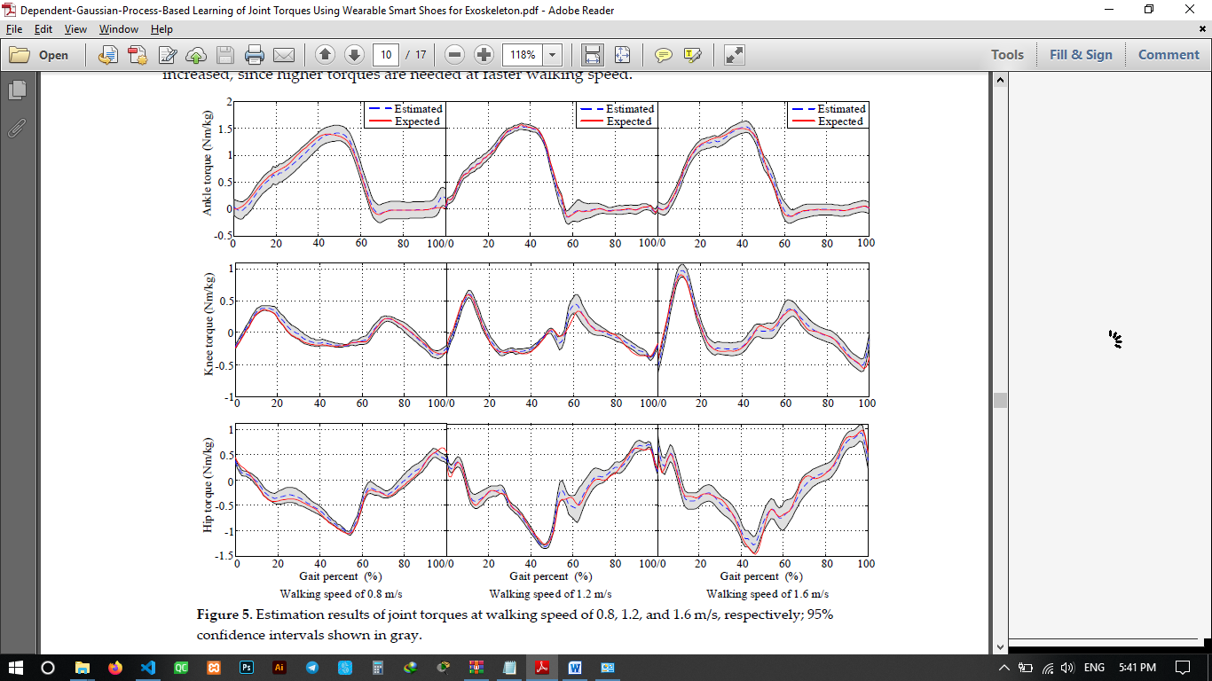

torques tended to change magnitude with walking speed. As walking speed increased, the joint torques increased, since higher torques are needed at faster walking speed.

the GP model was used for estimating the joint torques when the context was the same as that of the DGP model during the estimation and 20% of the *r*2 values were lower than 0.6.